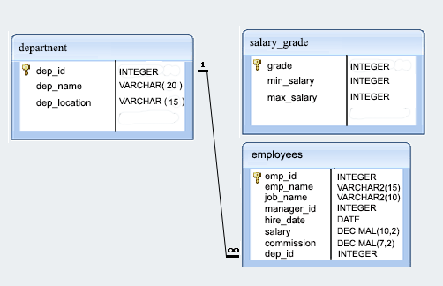

1. From the following table return complete information about the employees.

🡪SELECT * FROM employees;

1. From the following table, write a SQL query to find the salaries of all employees. Return salary.

🡪 SELECT salary FROM employees;

1. From the following table, write a SQL query to find the unique designations of the employees. Return job name.

🡪 SELECT DISTINCT job_name FROM employees;

**4.** From the following table, write a SQL query to list the employees’ name, increased their salary by 15%, and expressed as number of Dollars.

🡪SELECT name, ROUND(salary * 1.15, 2) AS increased_salary

FROM employees;

**5.** From the following table, write a SQL query to list the employee's name and job name as a format of "Employee & Job".

🡪SELECT CONCAT(name, ' & ', job_name) AS employee_job

FROM employees;

**6.** Write a query in SQL to produce the output of employees as follows.  
Employee  
Meera(manager).

🡪SELECT CONCAT(name, ' (', job_name, ')') AS Employee

FROM employees;

**7.** From the following table, write a SQL query to count the number of characters except the spaces for each employee name. Return employee name length.

🡪SELECT name, LENGTH(REPLACE(name, ' ', '')) AS name_length

FROM employees;

**8.** From the following table, write a SQL query to find the employee ID, salary, and commission of all the employees.

🡪SELECT employee_id, salary, commission

FROM employees;

**9.** From the following table, write a SQL query to find the unique department with jobs. Return department ID, Job name.

🡪SELECT DISTINCT department_id, job_name

FROM employees;